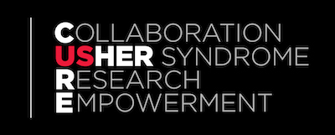
CUREUsher
We are a UK based, registered charity primarily focusing on Usher syndrome and those with combined hearing and sight loss.
We play a positive role in developing and embedding awareness campaigns across all genres, including schools, the NHS and the wider public.
Our ultimate aim is to raise awareness and funds for sight saving research.

THE STORY OF USHER SYNDROME:
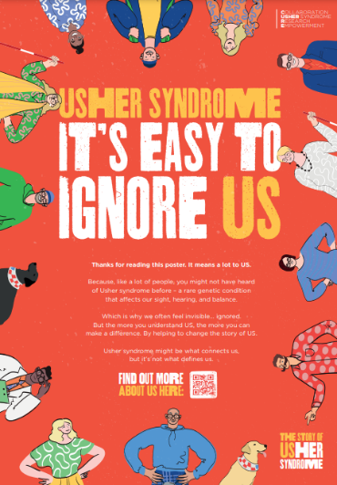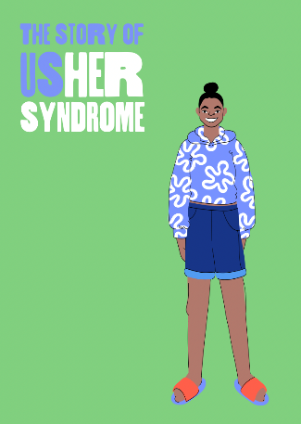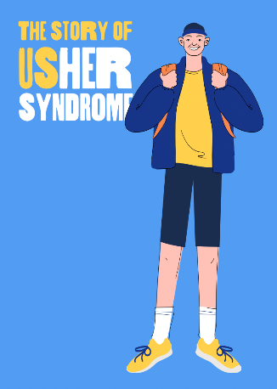
Gateshead born Jo Milne was born profoundly deaf and diagnosed with Usher syndrome in her late 20s; inspired by her experience with the condition, she founded CureUsher in 2018. She has worked in Bangladesh bringing hearing aids to disadvantaged children, and featured in the award winning BBC documentary, The Gift of Hearing. She has also campaigned tirelessly to have BSL recognised as an official language.
The charity has grown rapidly over the last 12 months successfully engaging with Westminster to form an All Party Parliamentary Group (APPG) and has a strong partnership with Northumbria NHS Foundation Trust, creating an educational film and resources for healthcare professionals, with the ambition to make this available nationwide.
Please use this link to view the video we have produced:
https://www.northumbria.nhs.uk/northumbria-healthcare-teams-up-with-jo-milne-to-launch-film-with-backing-from-the-osmonds/#308e1435
We also organise a range of fundraising events throughout the year including Great Runs and Swims across the UK as well as many musical and community events in the region.
To contribute to our vital work, we are looking to widen our Board of Trustees with particular experience in:
- Marketing & Social Media
- Business Sector
- Event planning
- Legal
- Fundraising

For further details, please contact our Chair Keith Hardy via secretariat@cureusher.org or visit our website at https://www.cureusher.org/

